327 Broadway Ave., #8

P.O. Box 7017

Yankton, SD 57078

Phone: 605.760.4825

casadiaperdepot@gmail.com

Please consider donating to the **CASA Diaper Depot**

* Disposable diapers, sizes Newborn – 6
* Packs of baby wipes
* Financial support to purchase these items for babies in need

Host a diaper drive with your club, congregation, or friends

This is a collaborative effort involving the whole community

You can help local families in need

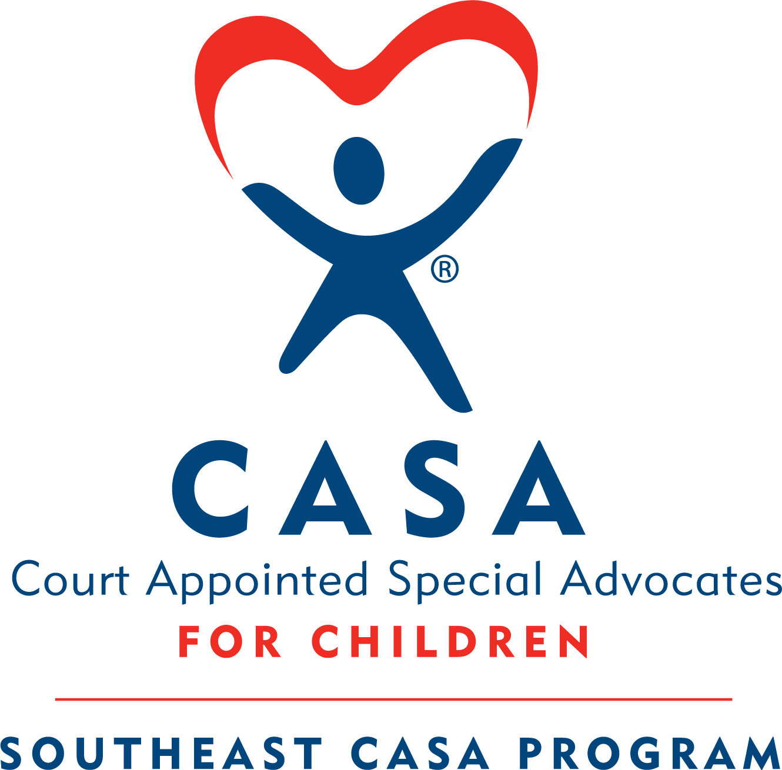

### How You Can Help

CASA Diaper Depot

#### Helping to Keep Local Babies Healthy and Happy!

A resource for qualifying families, so that everyone has access to a healthy change.

Parents must have a voucher from a partner agency in order to obtain a supplemental package of diapers.

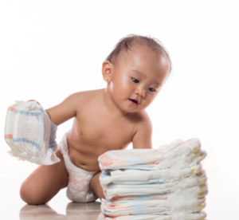

The **CASA Diaper Depot** needs your help!

You can provide the supplemental diapers and wipes for children in need.

Your donation of any size package of disposable diapers, baby wipes, or the funds to purchase them, helps children in Yankton County.

Call us: 605-760-4825

You can provide funds for this project by mailing a donation to the

**CASA Diaper Depot**

**P.O. Box 7017**

**Yankton, SD 57078**

### Did You Know?

#### How does the CASA Diaper Depot work?

The **CASA Diaper Depot** is a project that involves our partnering agencies and the families they serve.

* Pathways Shelter for the Homeless
* Lewis & Clark Behavioral Health Services
* River City Domestic Violence Center

#### Vouchers for Diapers

A partnering agency will determine who may get a voucher for a supplemental package of disposable diapers and baby wipes.

Vouchers must be turned in at the **CASA Diaper Depot**.

The **CASA Diaper Depot** is open for clients with a voucher on Thursday mornings, or by appointment made by calling 605-760-4825.

Clients may use the **CASA Diaper Depot** once a month.

1 in 3 families struggles to provide enough diapers for their children.

Diapers CANNOT be purchased with food stamps or WIC benefits.

Sometimes parents have to choose between diapers and other necessities, such as food or utilities.

Parents suffering from diaper need may have to leave baby in a soiled diaper for extended periods or even reuse previously soiled diapers.

Babies who remain too long in a soiled diaper are exposed to potential health risks.

Babies and toddlers cannot attend daycare without a supply of diapers and wipes. Parents cannot go to work if they can’t meet the requirements of the care providers.